Step 1 Clone the repository

Open Git hub page with the browser.

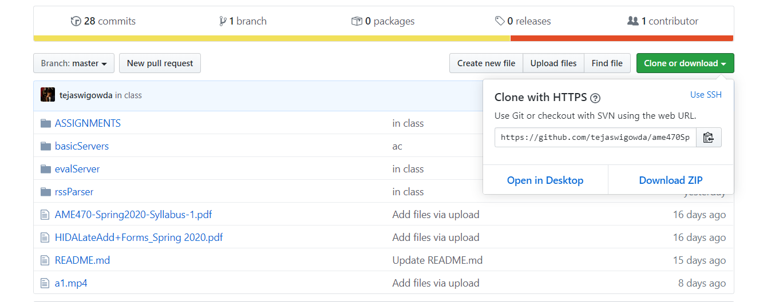

Then click download zip or just use git clone to clone the whole repository.

Step 2 Setup node.js

Open the link below

<https://nodejs.org/en/>

Then download and instill the 12.14.1 LTS version of node.js

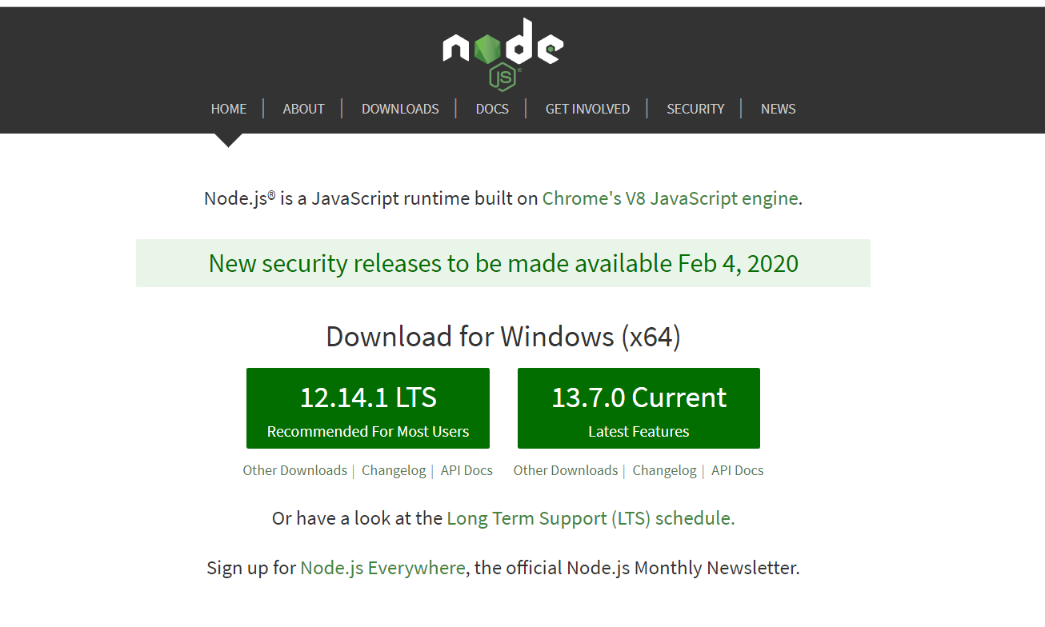

After finish instilling, open git bash and test if it’s instilled successfully.

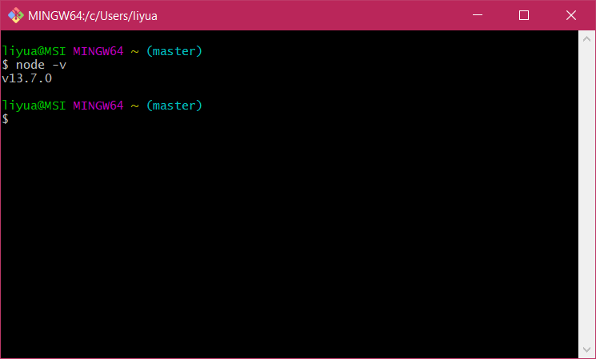

node -v

Step 3 Run the Server

First of all, use cd to located to the folder A2

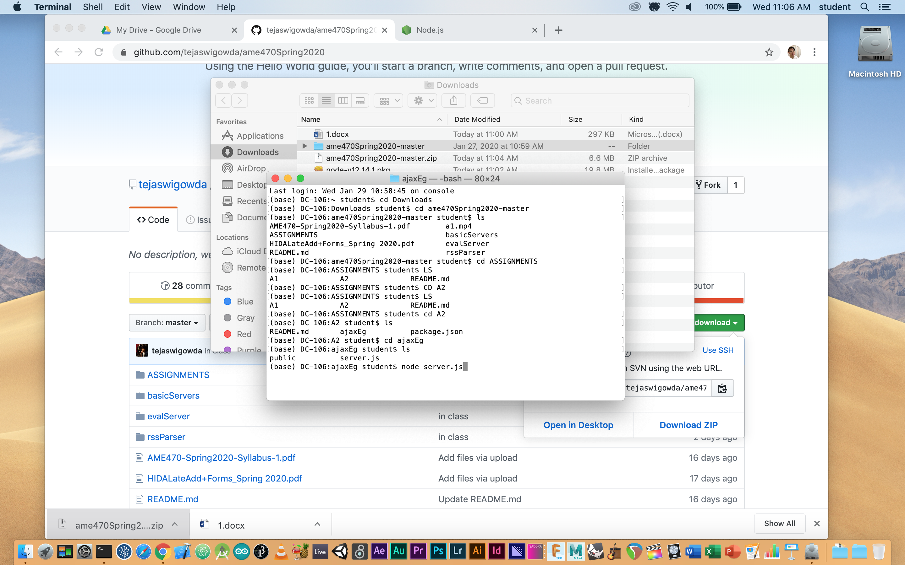

Then use node server.js to run the server

node server.js

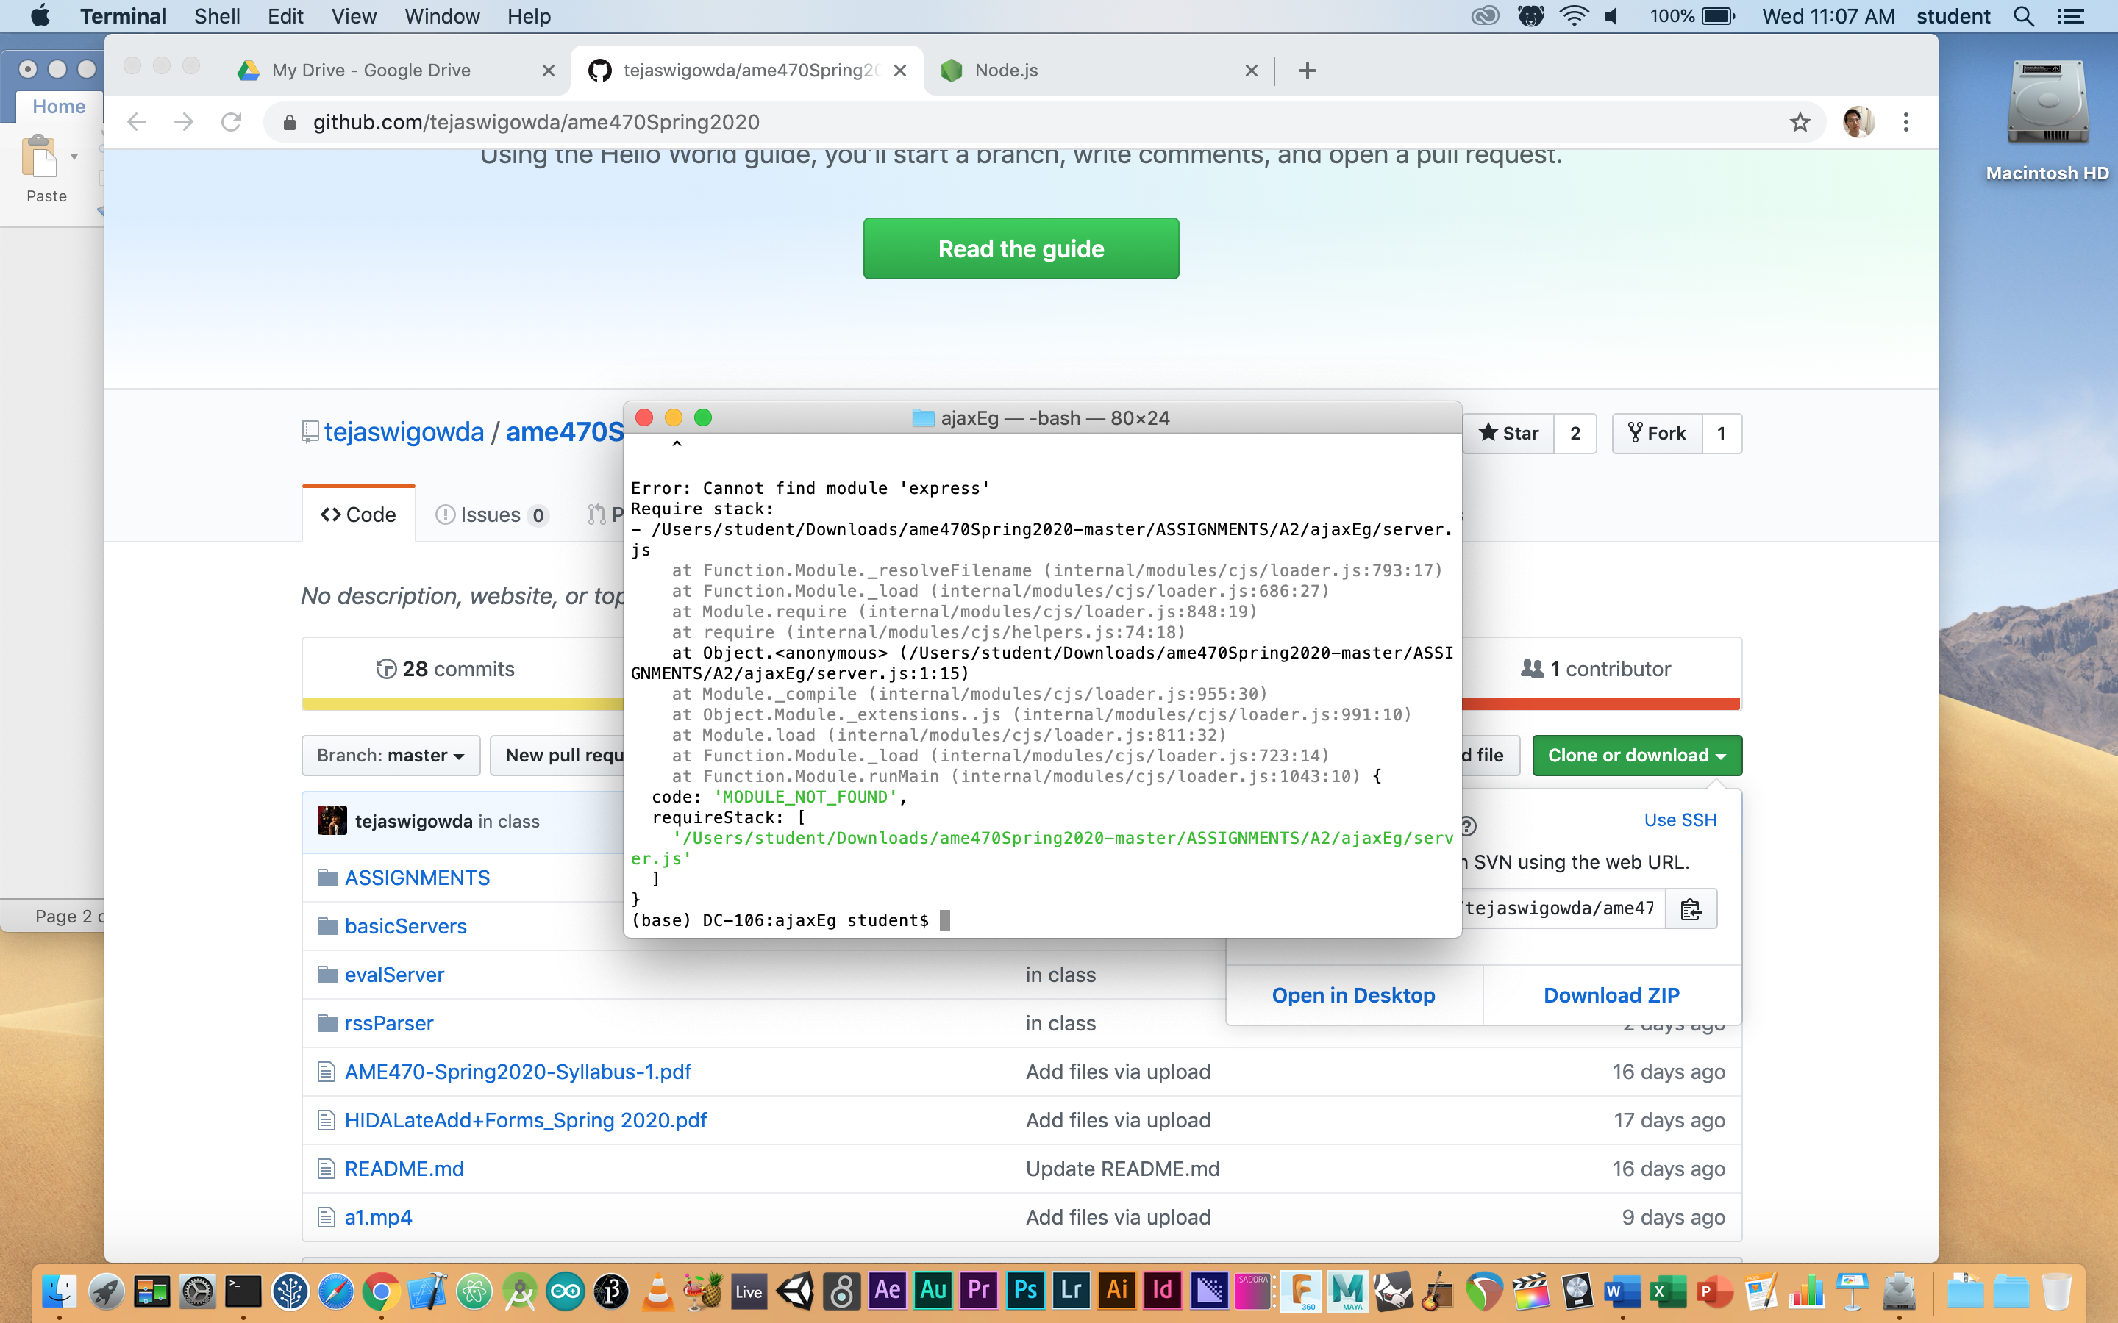

If something missed, use

npm (what u need) instill

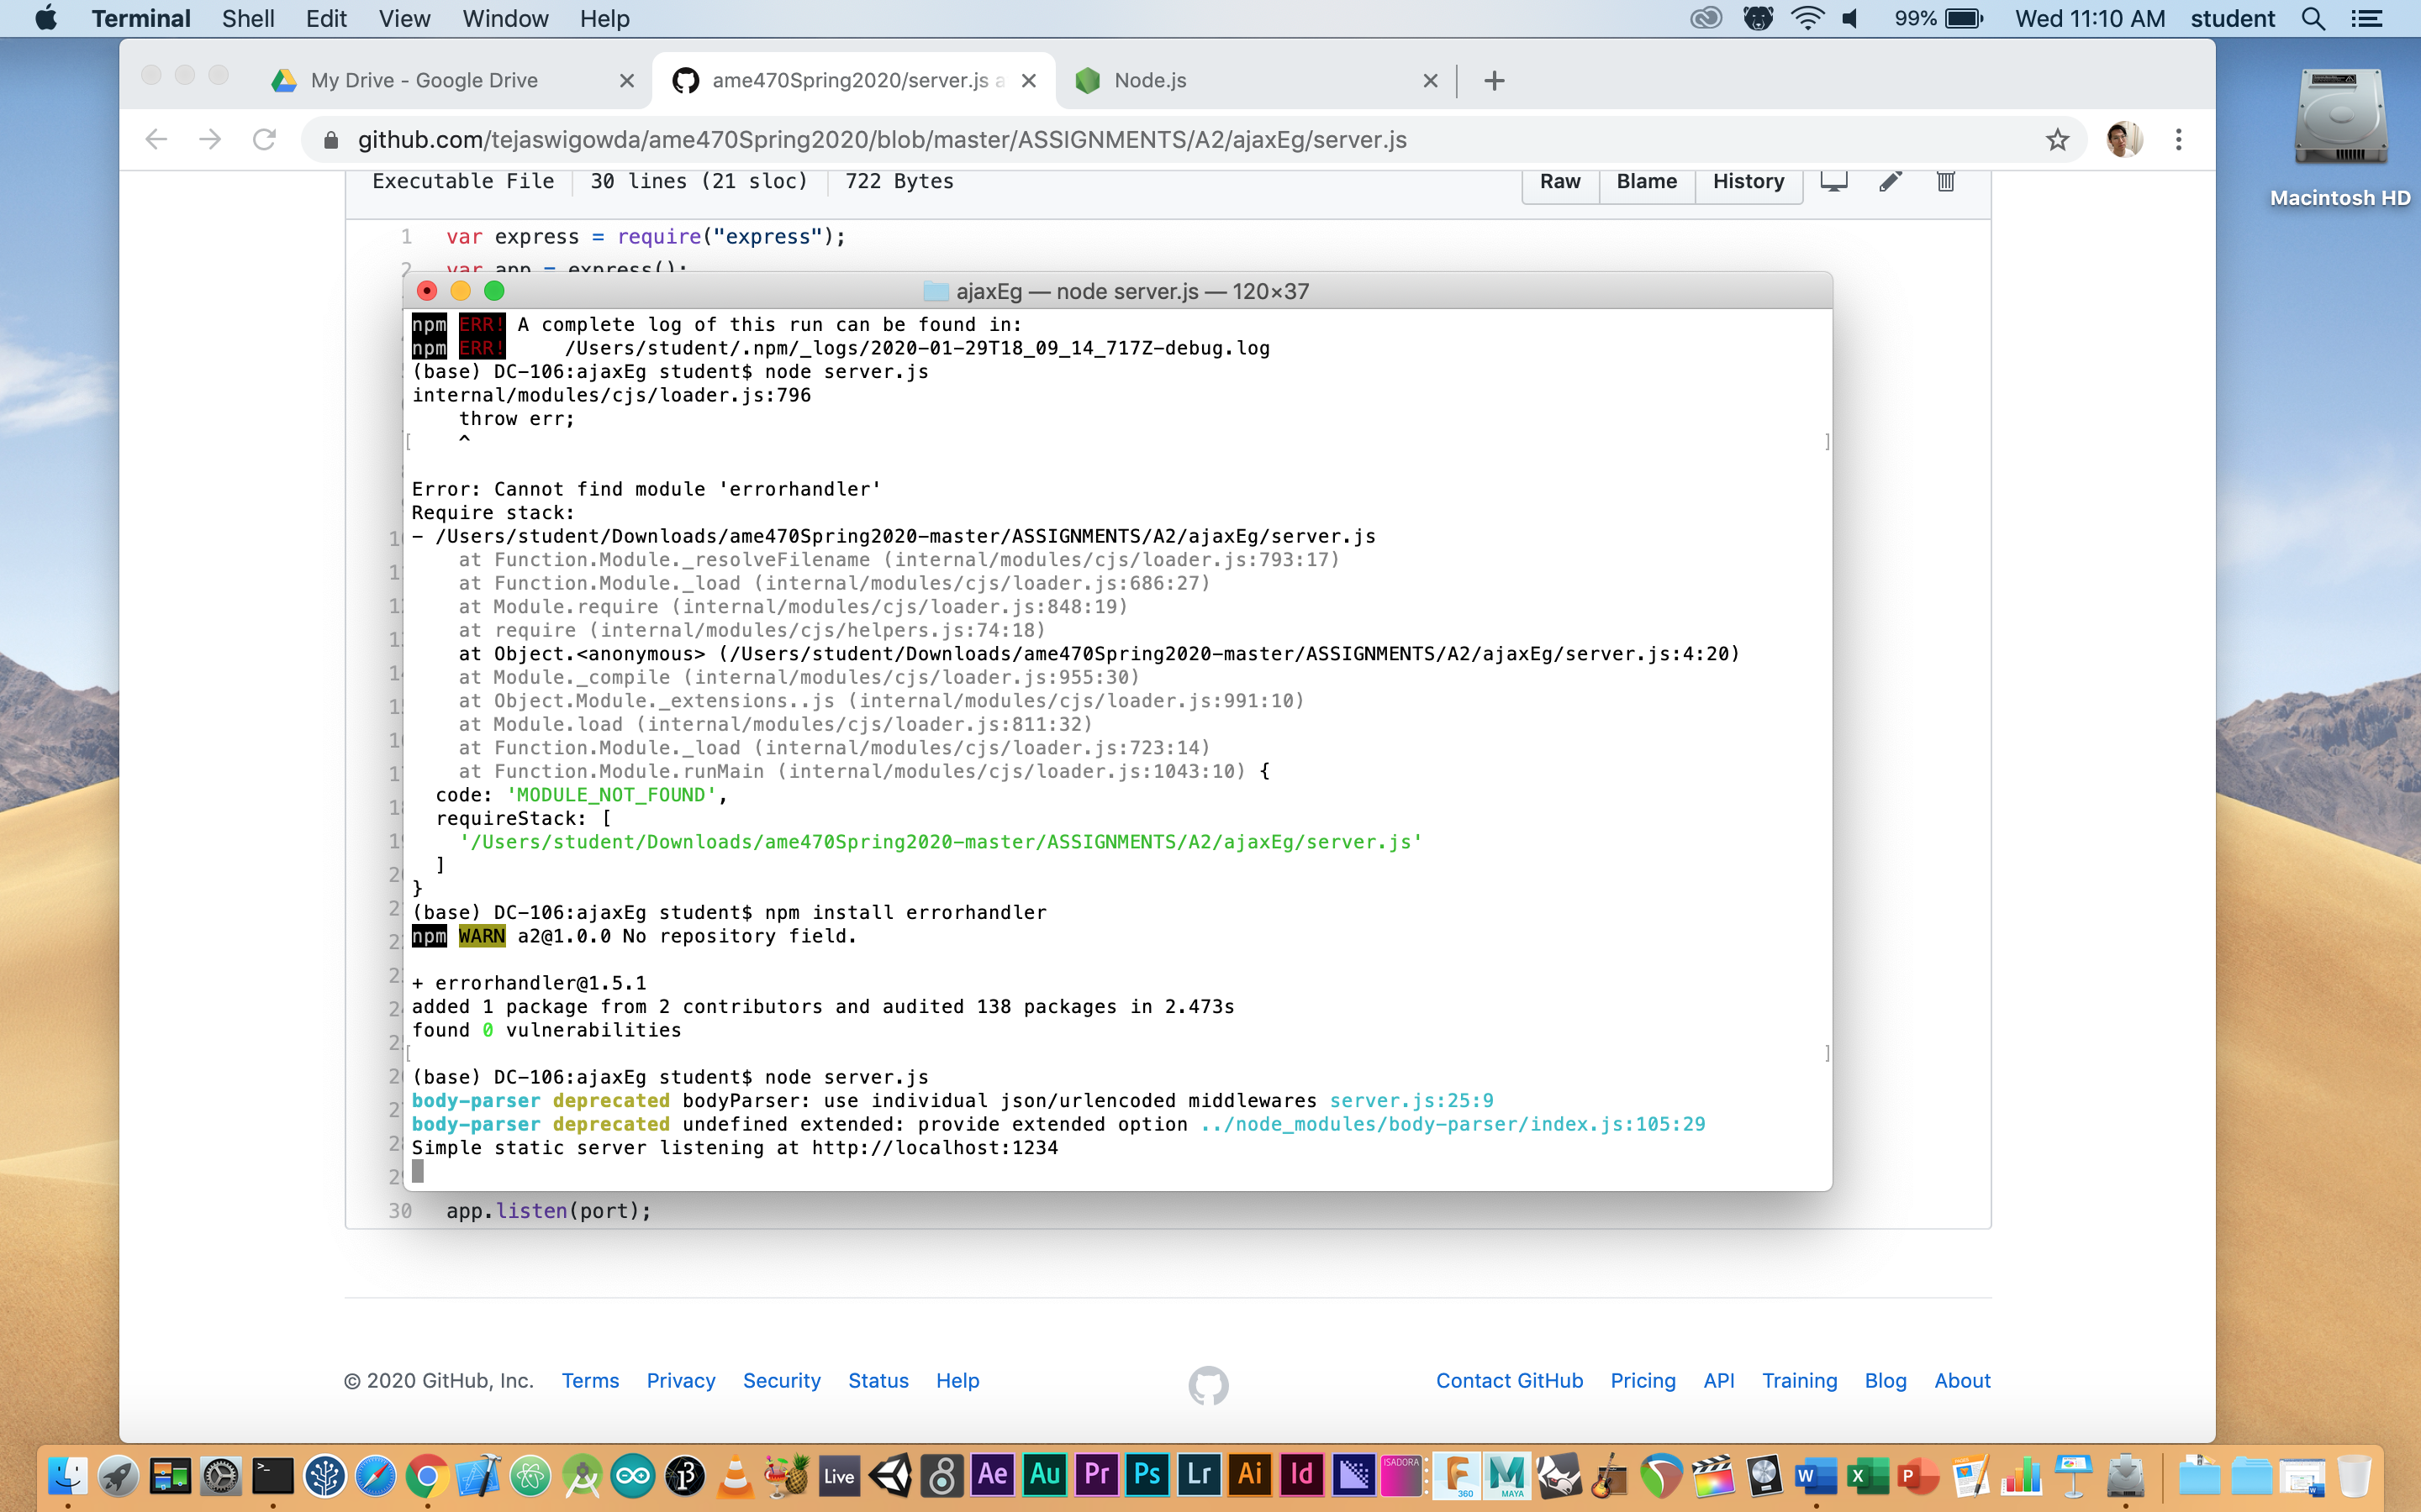

Then copy the link above to run the client server (index.html).

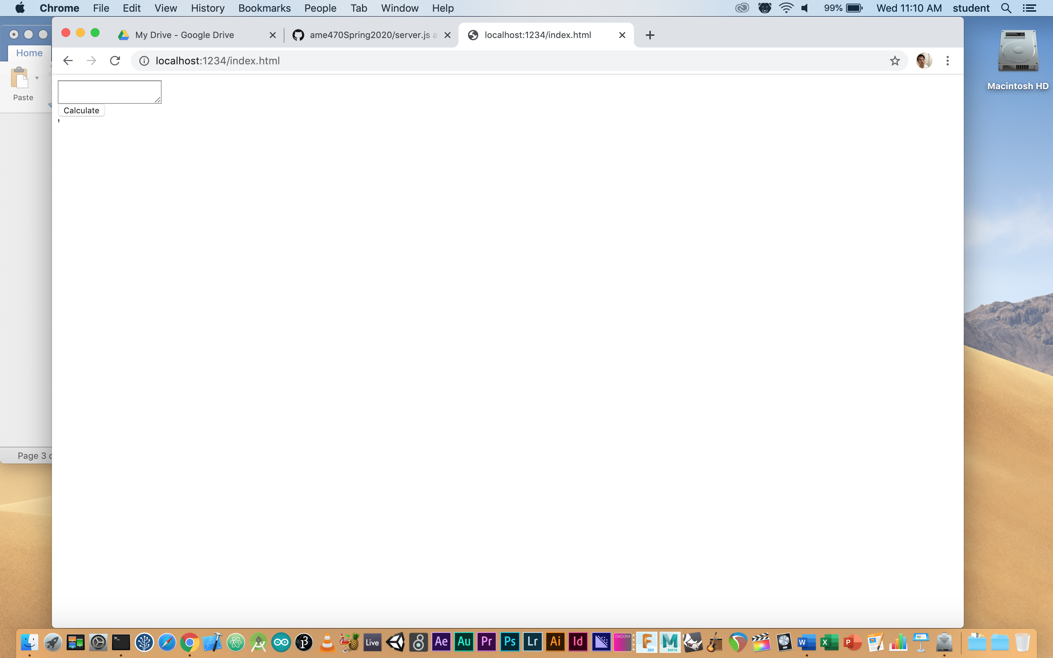

Text what you want to calculate, click the calculate bottom to send the request. Then the server will respond and send the value back to the client. <button onclick=”calc()> to the (/eval)

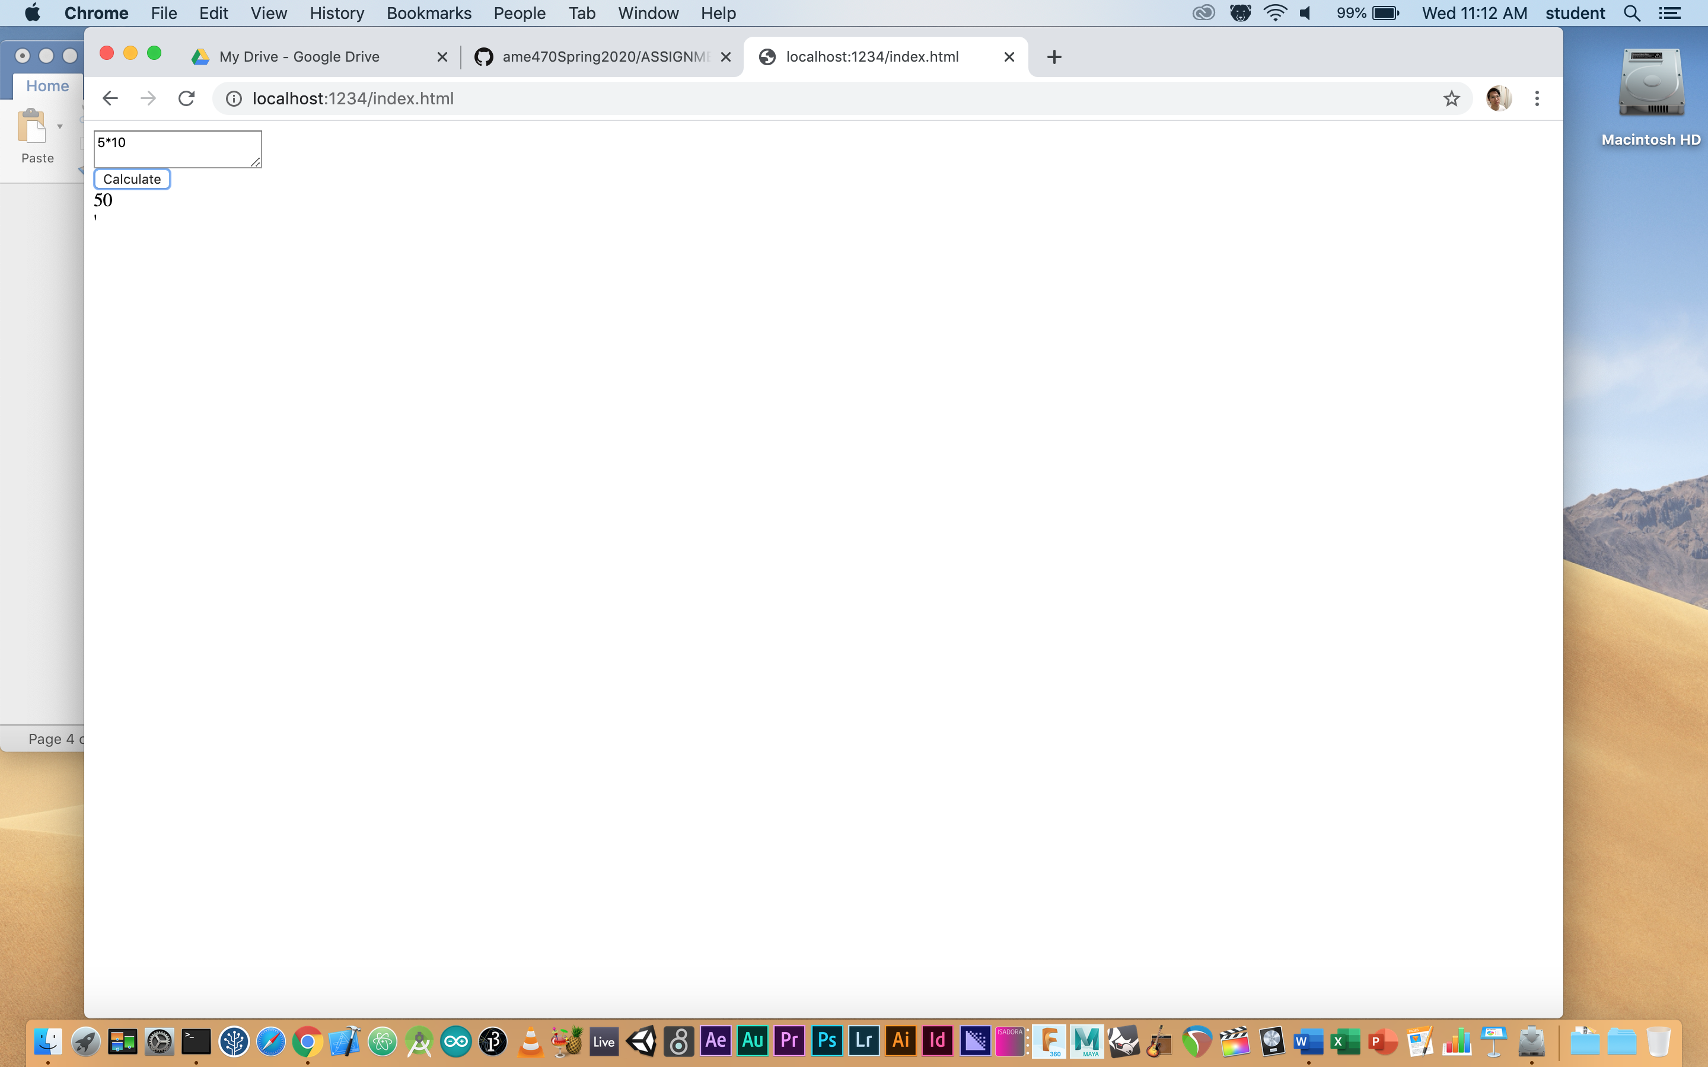

result <div id=”result”>6</div>.

